Van Nicolini Sosas

CMM-1163-C01

SPRINT PROJECT

Ideation of my Sprint Project

Character: **Gandalf the Grey in the Lord of the Rings**

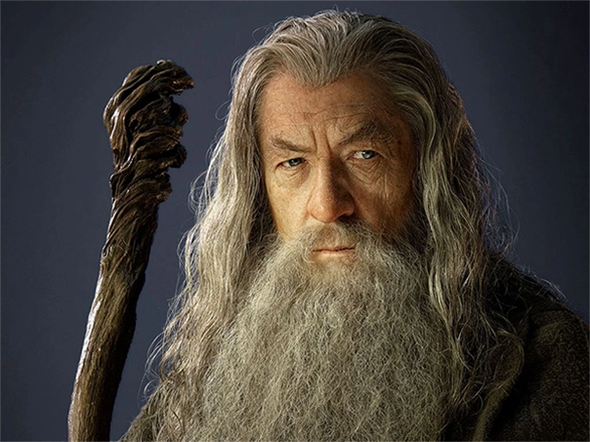

**SECTIONS:**

**About us section** - The Shire knows Gandalf the Grey as a funny old man who puts on fantastic fireworks displays. Frodo Baggins knows him as a friend and a mentor, full of wisdom and humour. He begins the quest by finding the Ring and is the first to say that it must be destroyed. He guides the Fellowship until his fall in Moria — and when he defeats the Balrog and returns, he continues to guide events.

**Biography section** - In Valinor, Gandalf was called Olórin. He was one of the Maiar of Valinor, specifically, one of the people of the Vala Manwë. He was said to be the wisest of the Maiar. As one of the Maiar, Gandalf was not a mortal man but an angelic being who had taken human form. As one of those spirits, Gandalf was in service to the Creator. Along with the other Maiar who entered into Middle-earth as the five Wizards, he took on the specific form of an old man as a sign of his humility. The role of the wizards was to advise and counsel but never to attempt to match Sauron's strength with their own.

Each Wizard is distinguished by the colour of his cloak. For most of his manifestation as a wizard, Gandalf's cloak is grey, hence the names Gandalf the Grey and Greyhame, from Old English hame, "cover, skin". Mithrandir is a name in Sindarin meaning "the Grey Pilgrim" or the Grey Wanderer.

**Personality section** - Gandalf is often described in The Lord of the Rings as quick to anger, and equally quick to laugh. His deep wisdom is clearly derived from the patience he learned in Valinor, just as his care for all creatures of good will must have come from his strong sense of pity for the weak. Both his patience and sense of pity were revealed repeatedly, extending even to the servants of his enemies.

Hobbits appealed to him more than to the other Wizards, and he went often to the Shire for respites from his errands. It may be that he was amused by their nature. It is because they were untouched by the great evils of the world and were more in touch with nature than men.

**Skills section** - Gandalf demonstrated extensive knowledge of the land and an assortment of magical abilities from trivial to essential. He created blinding flashes and other pyrotechnics to distract the goblins of the Misty Mountains, aiding the dwarves in their escape from Goblin-town. Though not as keen as Elves, his eyesight was sharp enough to not only see in darkness but also see in the dimension of the Nazgûl.

His great intelligence allowed him to accurately guess the thoughts of others and made him perhaps the preeminent architect of Sauron's defeat. Moreover, Gandalf was skilled at telling men things that were true from a certain point of view. Gandalf speaks words of power. Gandalf described himself as "a servant of the Secret Fire, wielder of the flame of Anor". Coincidentally, many of his spells were based on light and fire. When angered or aroused for battle, he seemed to grow in height and assume a terrifying aspect.

Armed with an Elven blade, Gandalf was as valiant a fighter as the other swordsmen in the Fellowship, in no way hindered by his elderly appearance when fighting or riding. Gandalf the Grey has command over a great array of spells for all situations, such as magically healing wounds, and sealing doors shut or open them. Gandalf also could make illusions such as when he covered Bilbo's use of the One Ring at his party. Gandalf once had a comprehensive knowledge of Orc, Elf, and Manish magic.